205 CDE reflective report

By Derons Chan

Project link: <https://github.com/derons888/205CDE>

Presentation link: <https://www.youtube.com/watch?v=PUCAG3RcpEw>

Introduction

Technology is advancing everyday. Internet is becoming more and more popular. More and more people will use internet for shopping as it is more convenient. Most company have extended their business to online shopping. The aim of this project is to provides business solutions to a company. It provides ways for company to sell their products through a website. It can let users to login, check for order record.

Technologies Used

1. **Flask**

Flask is a micro web framework written in Python. It is classified as microframework because it does not require particular tools or libraries. It is used for web development.

from flask import Flask, request, session, render_template, redirect, url_for, flash

The above code shows how to import flask into the environment for this project.

@app.route('/')

@app.route('/home')

def home():

return render_template('home.html')

This code shows how to set up the path of the first page when the page is opened.

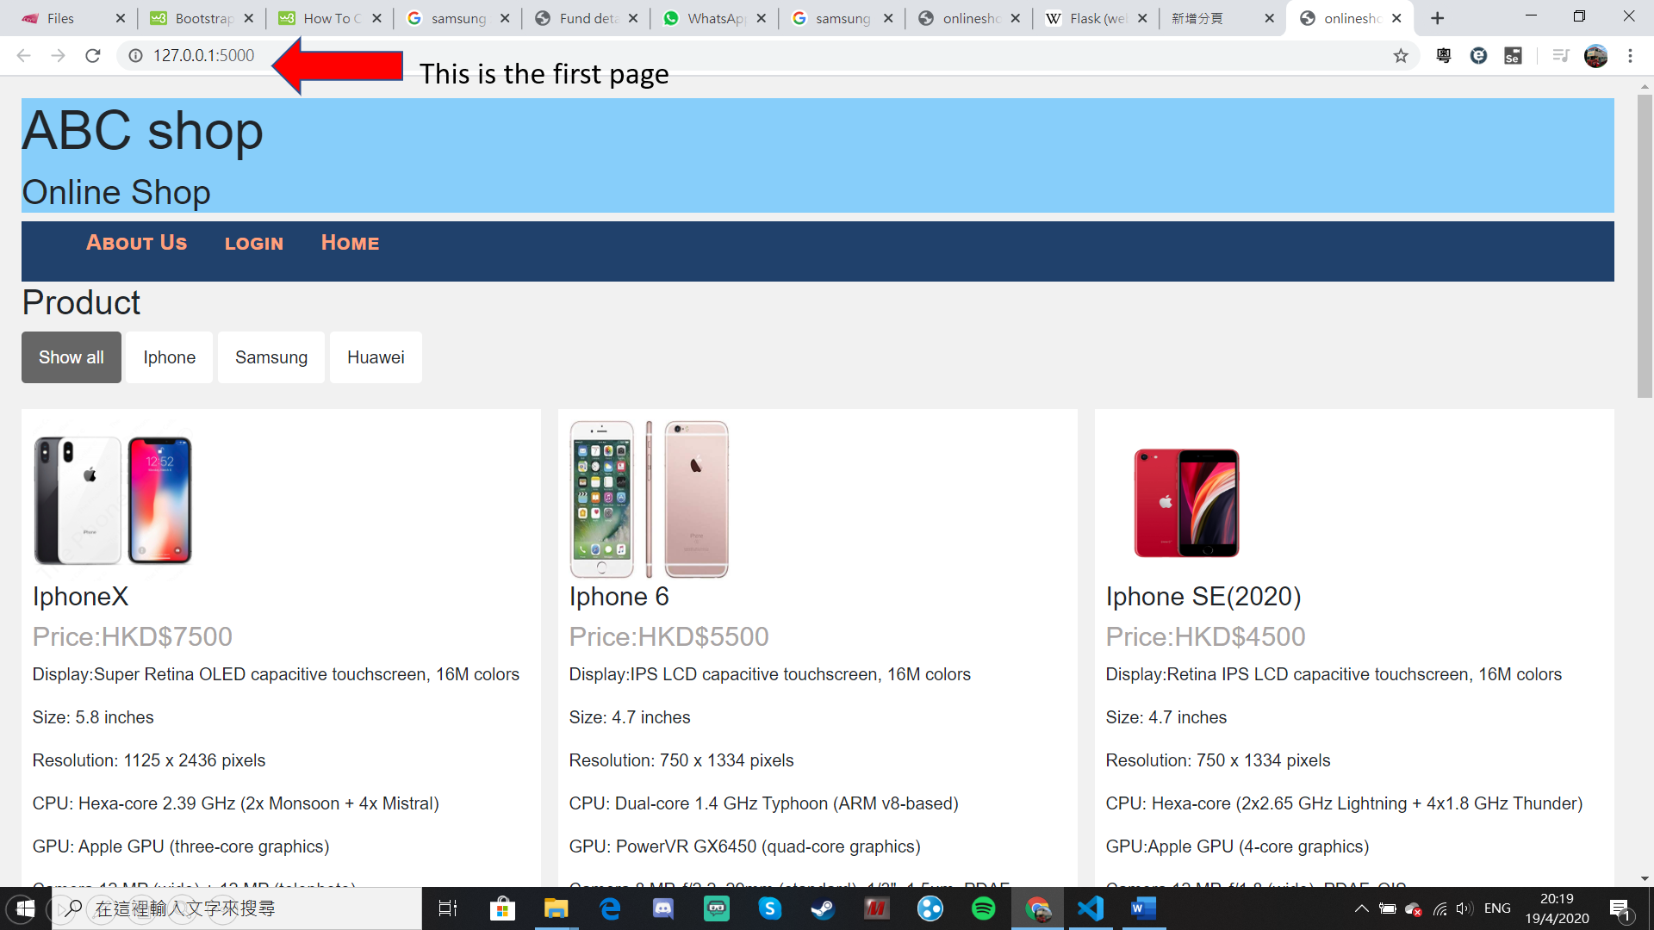

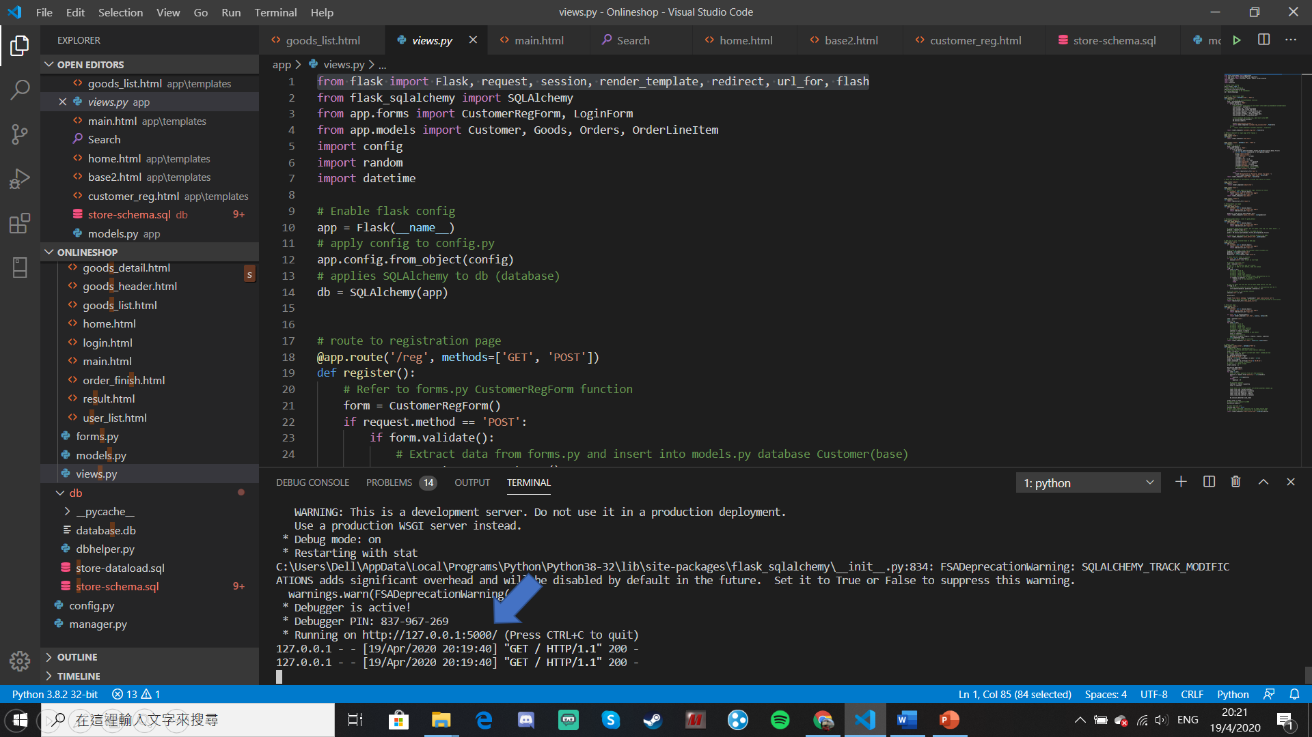

1. **Sqlalchamy**

SQLAlchemy is the Python SQL toolkit and Object Relational Mapper that gives application developers the full power and flexibility of SQL.

from sqlalchemy import Column, ForeignKey, String, Integer, Float

from sqlalchemy.orm import relationship

from sqlalchemy.ext.declarative import declarative_base

The above statement shows how to import the sqlalchemy into the program.

create table Customers

(

id varchar(20) primary key,

name varchar(50) not null,

password varchar(20) not null,

address varchar(100),

phone varchar(20),

birthday varchar(20)

);

These are SQL language, which is to create a table in the SQL server.

@manager.command

def load_data():

dbhelper.load_data()

It is the command to load the data from the database and upload to the web.

The following is the database diagram of the database

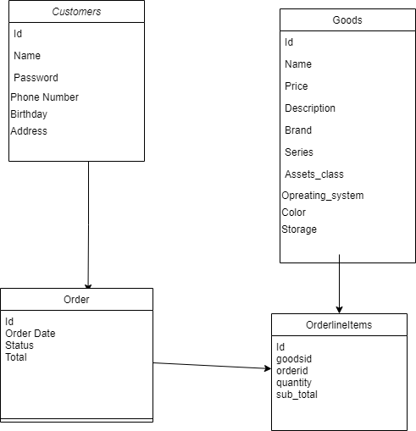

1. **WTForm**

WTForm is used for data validation. It can help to check whether the user has input wrong data.

class CustomerRegForm(Form):

'''User Register Form validation'''

userid = StringField('UserID：', [validators.DataRequired(message='UserID input is mandatory')])

name = StringField('User Full Name：', [validators.DataRequired(message='Username input is mandatory')])

password = PasswordField('User Password：', [validators.DataRequired(message='Password input is mandatory')])

password2 = PasswordField('Re-Enter Password：', [validators.EqualTo('password', message='Input password is not consistent')])

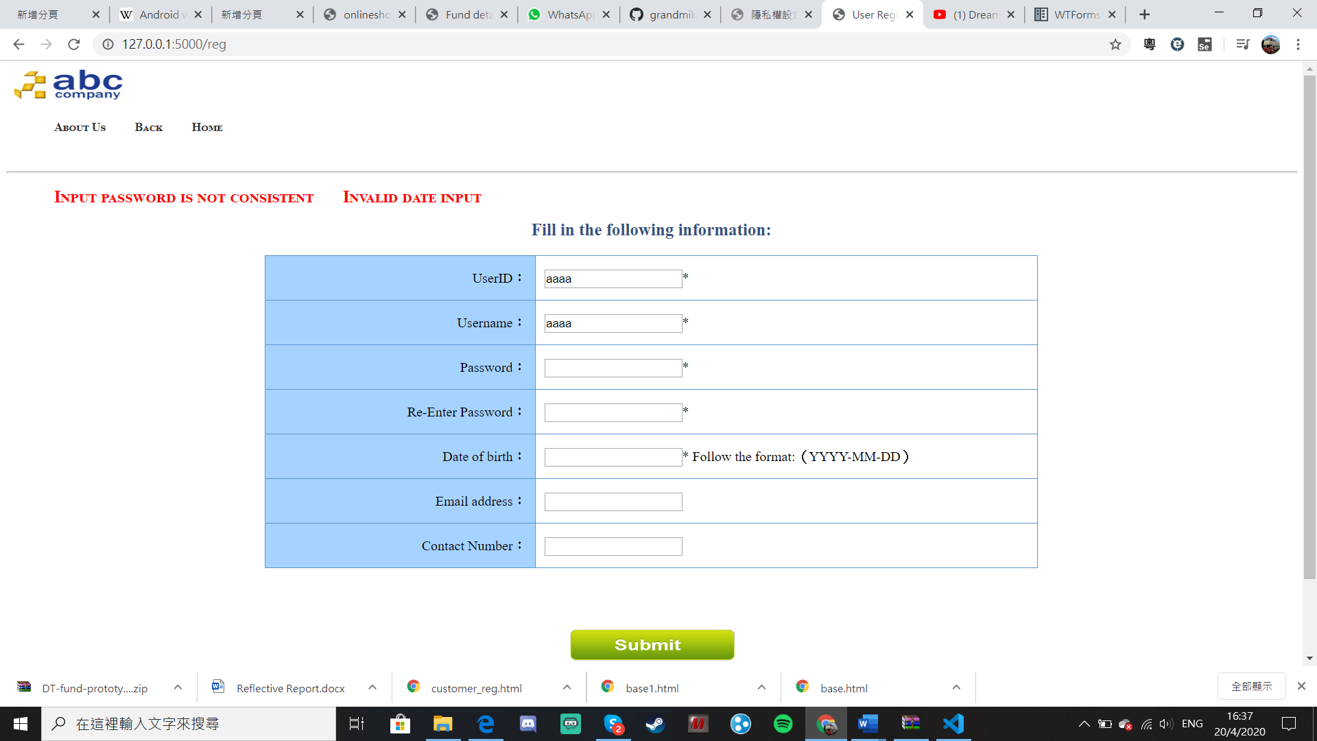

When user input wrong data, it will pop up aleret message, which is shown by the red word.

1. **Bootstrap**

Bootstrap is an open source toolkit for developing with HTML, CSS, and JS. It can make responsive button and animation in the web, and make the webpage more beautiful.

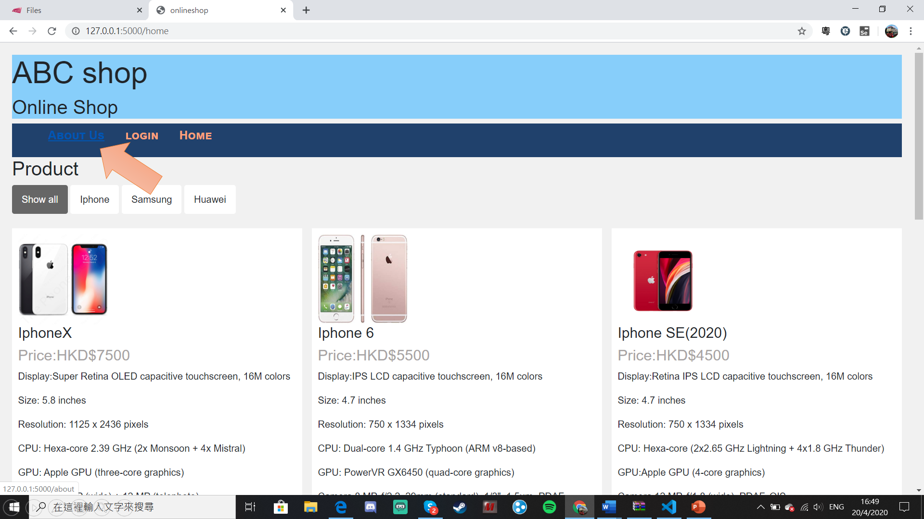

For example, the navigation bar uses bootstrap. When you click on “About Us”, the colour will change to blue.

<meta name="viewport" content="width=device-width, initial-scale=1">

<link rel="stylesheet" href="https://maxcdn.bootstrapcdn.com/bootstrap/4.4.1/css/bootstrap.min.css">

<script src="https://ajax.googleapis.com/ajax/libs/jquery/3.4.1/jquery.min.js"></script>

<script src="https://cdnjs.cloudflare.com/ajax/libs/popper.js/1.16.0/umd/popper.min.js"></script>

<script src="https://maxcdn.bootstrapcdn.com/bootstrap/4.4.1/js/bootstrap.min.js"></script>

The links are added to the html file so that the bootstrap package can be used in my project.

1. **Javascript**

JavaScript is a language that supports event-driven, functional, and imperative programming styles. It has application programming interfaces (APIs) for working with text, dates,

<script>filterSelection("all") // Execute the function and show all columns

  function filterSelection(c) {

    var x, i;

    x = document.getElementsByClassName("column");

    if (c == "all") c = "";

    // Add the "show" class (display:block) to the filtered elements, and remove the "show" class from the elements that are not selected

    for (i = 0; i < x.length; i++) {

      w3RemoveClass(x[i], "show");

      if (x[i].className.indexOf(c) > -1) w3AddClass(x[i], "show");

    }

  }

  // Show filtered elements

  function w3AddClass(element, name) {

    var i, arr1, arr2;

    arr1 = element.className.split(" ");

    arr2 = name.split(" ");

    for (i = 0; i < arr2.length; i++) {

      if (arr1.indexOf(arr2[i]) == -1) {

        element.className += " " + arr2[i];

      }

    }

  }

  // Hide elements that are not selected

  function w3RemoveClass(element, name) {

    var i, arr1, arr2;

    arr1 = element.className.split(" ");

    arr2 = name.split(" ");

    for (i = 0; i < arr2.length; i++) {

      while (arr1.indexOf(arr2[i]) > -1) {

        arr1.splice(arr1.indexOf(arr2[i]), 1);

      }

    }

    element.className = arr1.join(" ");

  }

  // Add active class to the current button (highlight it)

  var btnContainer = document.getElementById("myBtnContainer");

  var btns = btnContainer.getElementsByClassName("btn");

  for (var i = 0; i < btns.length; i++) {

    btns[i].addEventListener("click", function(){

      var current = document.getElementsByClassName("active");

      current[0].className = current[0].className.replace(" active", "");

      this.className += " active";

    });

  }</script>

The Javascript allows users to select what they want to see. At first, it will show all products.

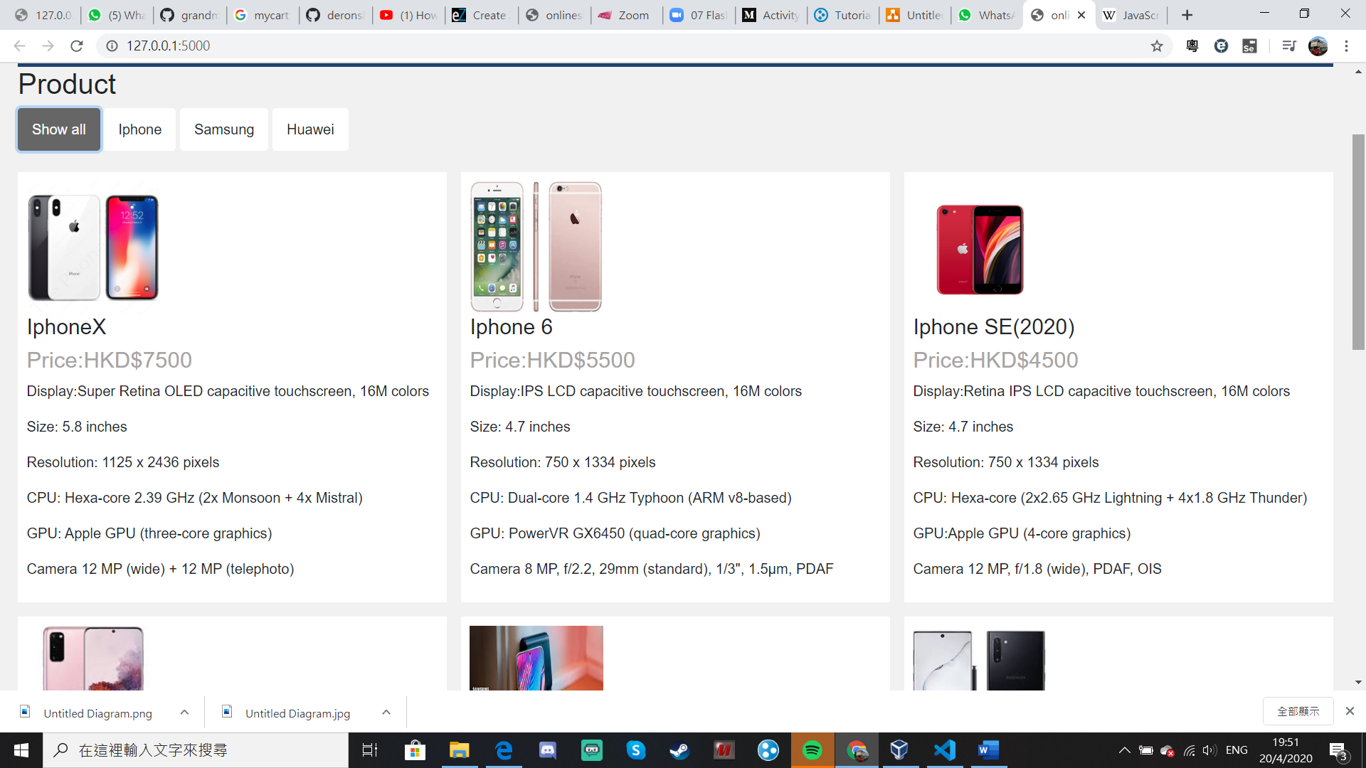

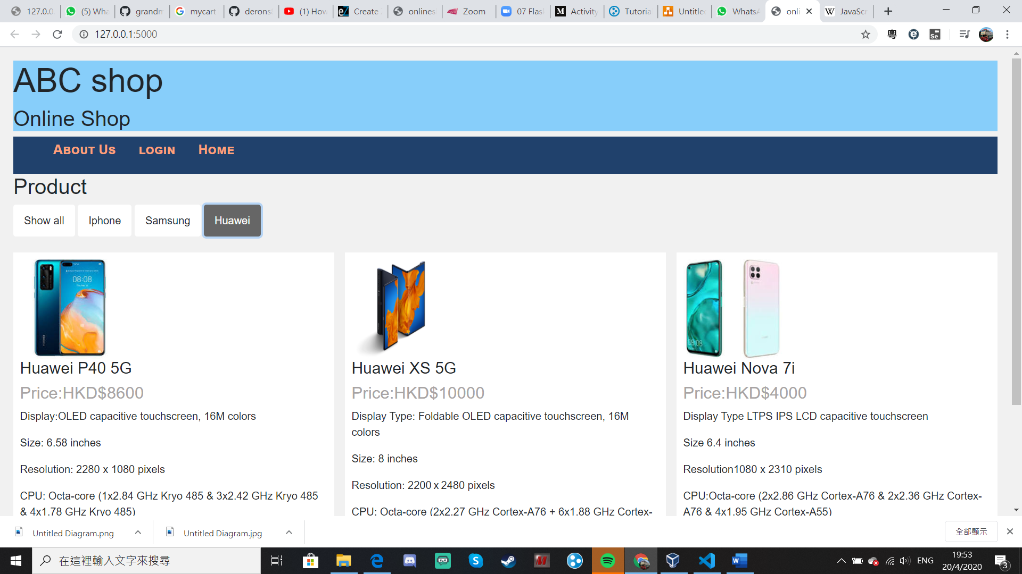

When the users select Huawei, it will just show the products related to Huawei.

**Features of the website**

1. By default it will show up all the products provided by our company in the home page. But users can choose what product brands they want to see by clicking on the filter.
2. Users can click “About Us” icon and they will be redirected to about us page. There they can see the introduction and background of the company, and the contact information.
3. When users click “login” they will be redirected to login page . Here they can type their username and password to login.
4. In the login page, users can register an account by clicking the “register” button. After that, users will be redirected to register page.
5. After login in, users can see the product list and add the products to the subscription cart.
6. In the subscription cart, users can see what products they have ordered and checkout for payment.

**Screenshot and details of the onlineshop**

When you click the “About Us”,you will be linked to the About Us page

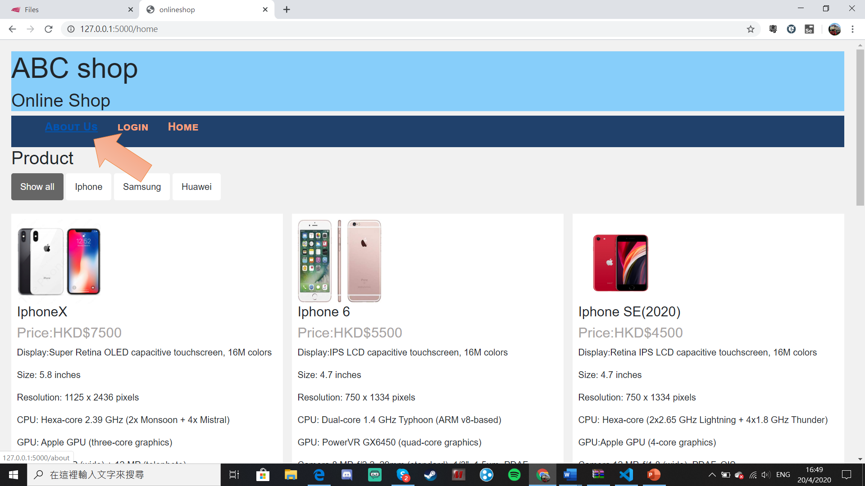

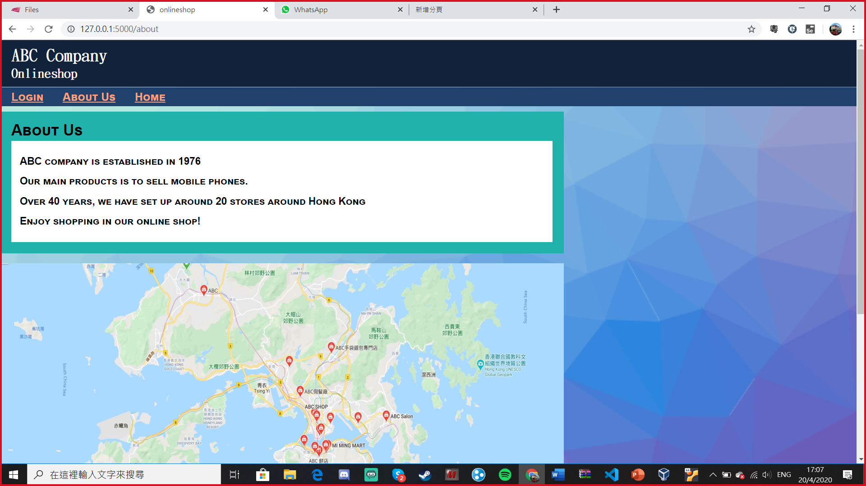

When you click the “login”, it will redirect you to login page

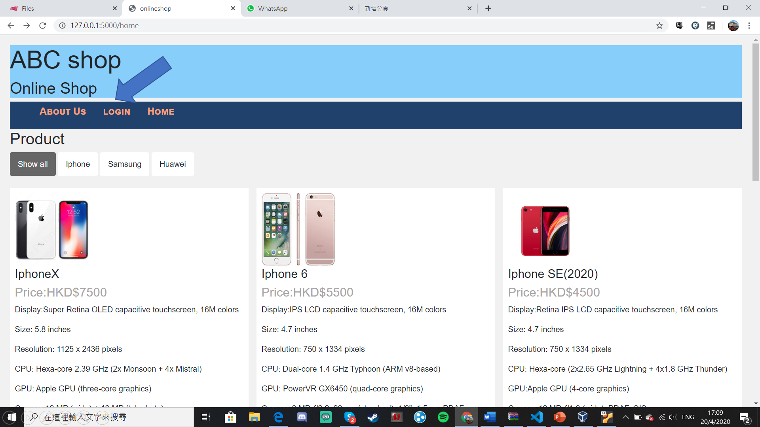

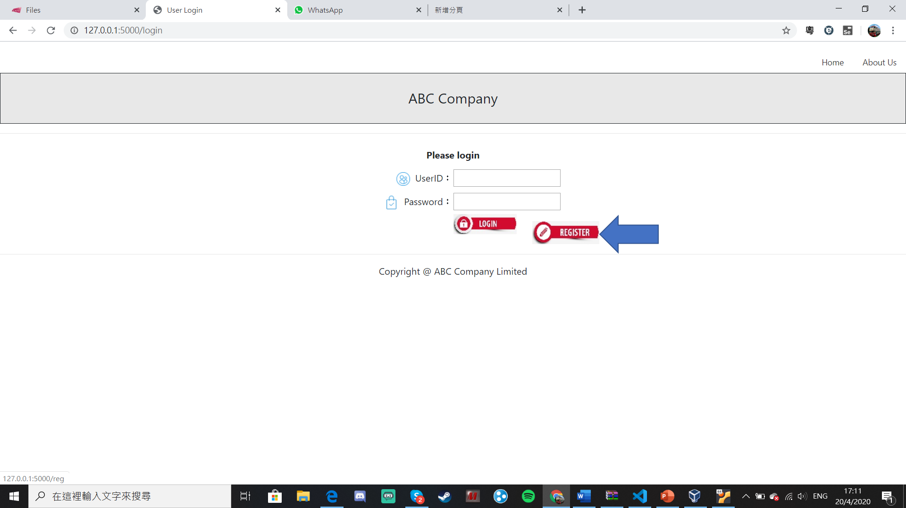

After you click the login page, you can click “register” for registration

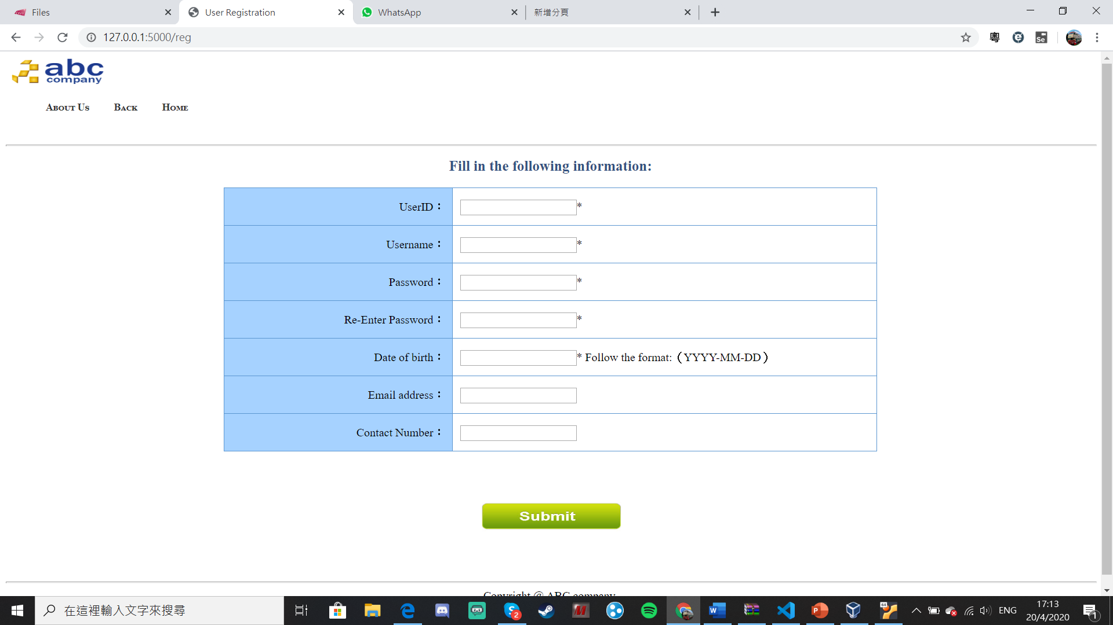

After login, you will see this page. You can find the products here.

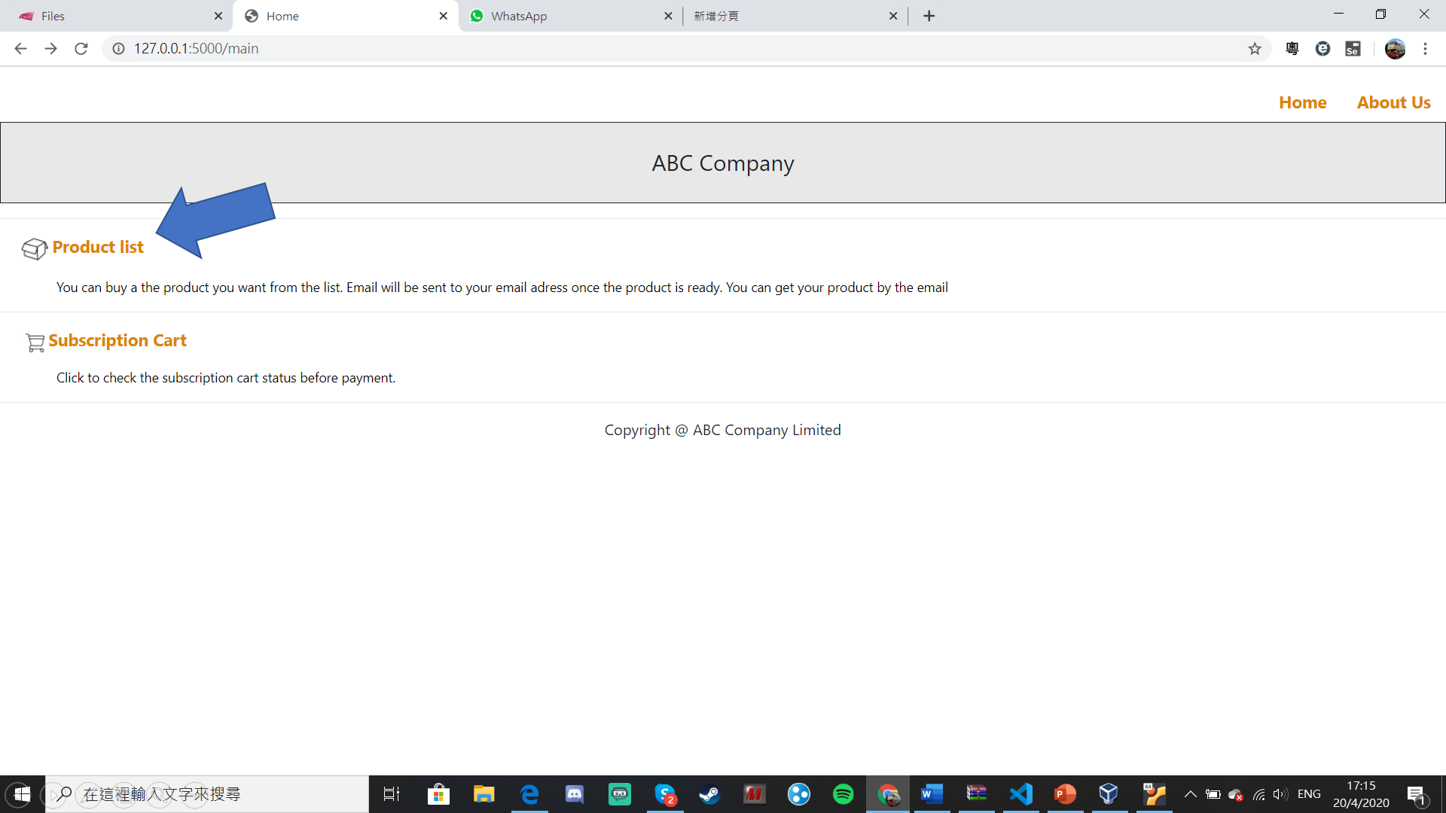

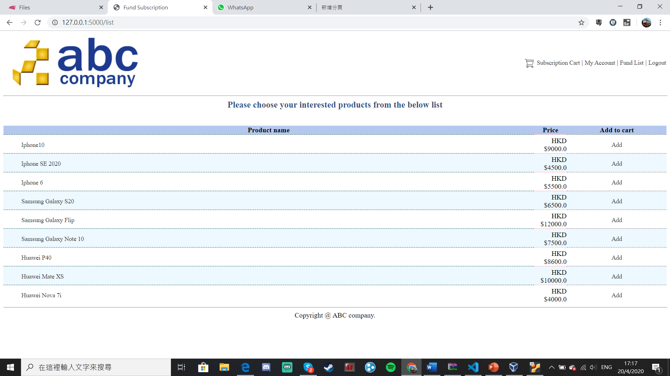

You can find your products here

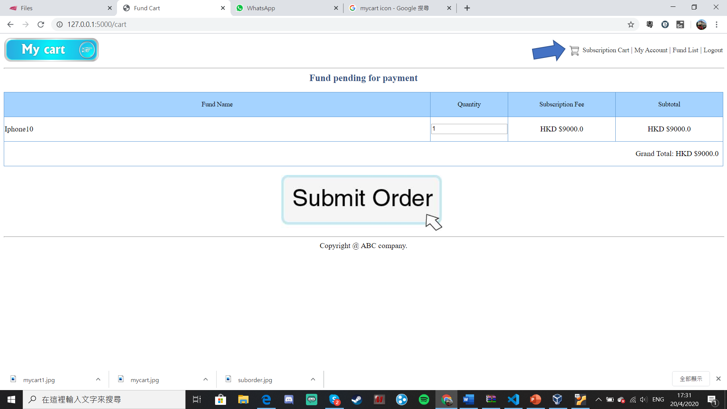

**Difficulties and Limitations**

1. Payment page is not set up.Most of the online payment are payed by credit card. But, the pagement system need to be linked to the validation page provided by creditcard issuer and bank, like Mastercard and Visa. Base on what we have learnt in the lesson, we didn’t have the technique to do that.
2. Time is not enough. Flask framework is the core of this project. However, it is taught in the last few weeks before the deadline. So little time is left for programming the code.
3. Flask is a completely new environment for me. I have to learn it from scratch. At first, it is difficult to link the database and the front-end webpage together. Luckily, with teacher’s supporting and online materials, I am able to do that at last.
4. Currently, the pictures in the home page is not interactive. Users cannot click on the picture and linked to the subscription cart.
5. Forget password function is not available. Users cannot find or reset the password if they lost the password.

**Improvement**

1. Make online payment page and link to Visa/Mastercard validation
2. Make the firstpage more interactive by bootstrap and Javascript.
3. Set up reset/forget password page to let users to change or recover their password.